Culturally Responsive Teaching for Special Education Children
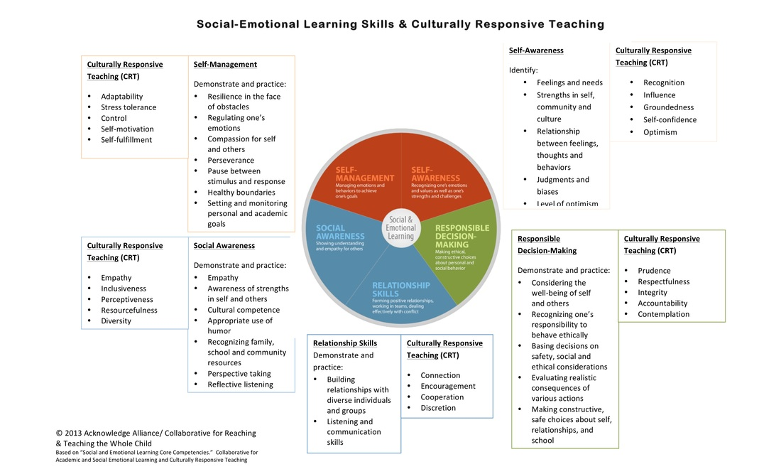

The following articles will provide more information about CRT with special education students:
Creating Culturally Responsive, Inclusive Classrooms
Culturally Responsive Teaching

This power point may also help you to convey this information to your colleagues:
Creating a Culturally Responsive Special Education Classroom
